LAB 2

Ben Giftakis

9/29/20

Screenshot:

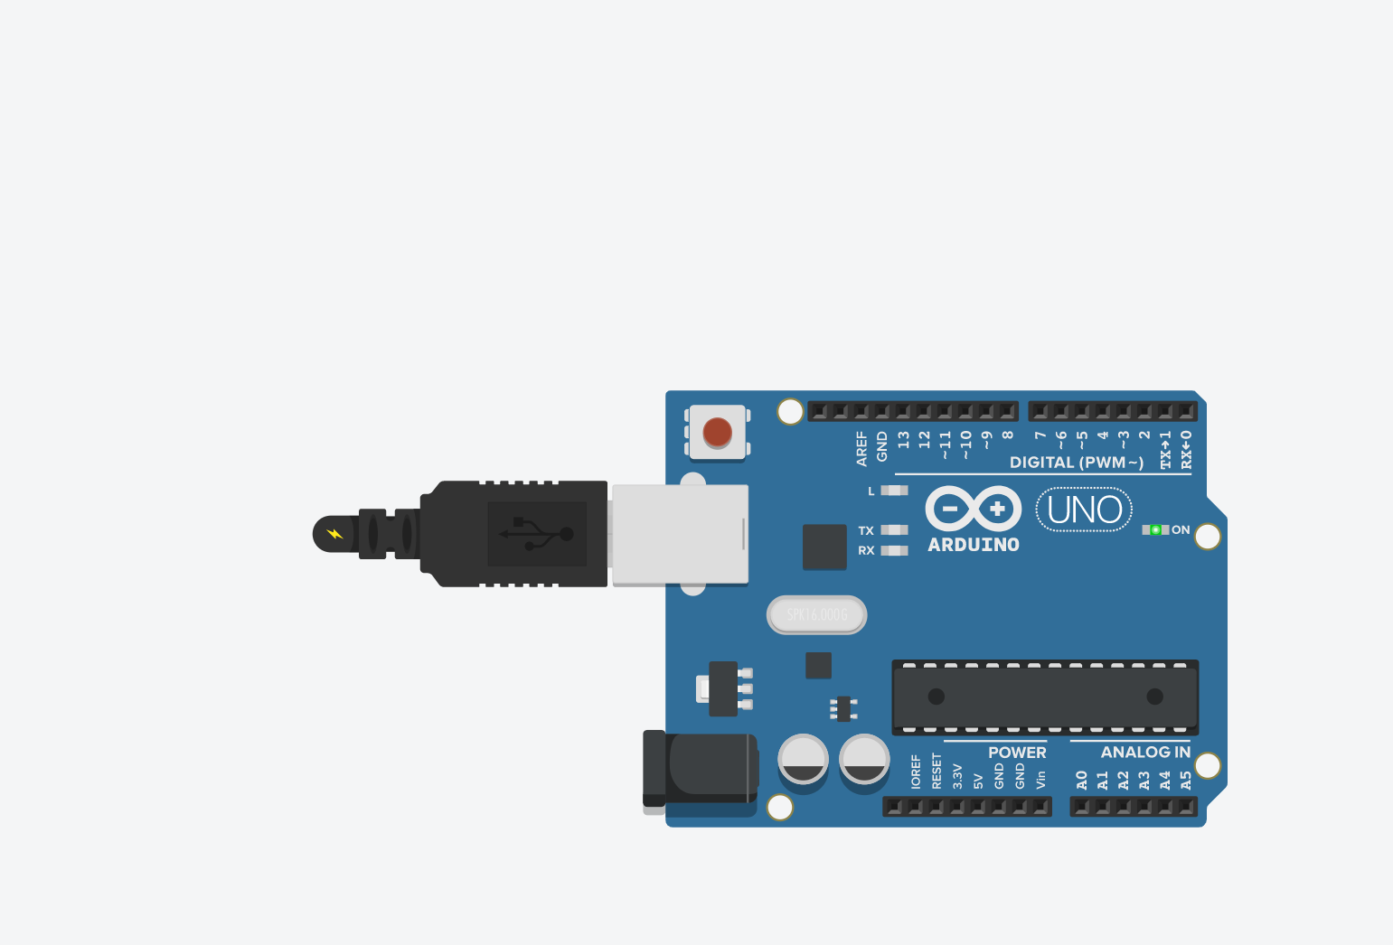

Arduino

Summary:

In this lab I reviewed the entire memory range and determined the location of the stack, heap and initialized data.

Results:

Part 1:

End of Flash: 7FFF

End of RAM: 8FF

End of EEPROM: 3FF

Part 2:

The stack is put in the high address range, or the bottom of the output, the heap data is put at the top but the initialized data is before the heap.

Part 3:

The stack starts around 0x1B0 and goes to 0x8FF

The heap starts at about 0x100 and goes to 0x250  
initialized data starts at 0x100 and goes to 0x3FF

Conclusion:

* Learned how the memory is allocated to different parts of code
* I found it frustrating the serial monitor can only display so many lines at a given time, this made it difficult to go back and check what was where.